•  [[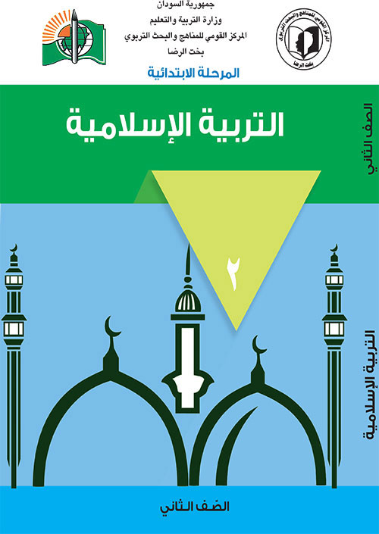](https://www.moe.gov.sd/primbk/islamic2.pdf)](https://www.moe.gov.sd/primbk/islamic2.pdf)

• [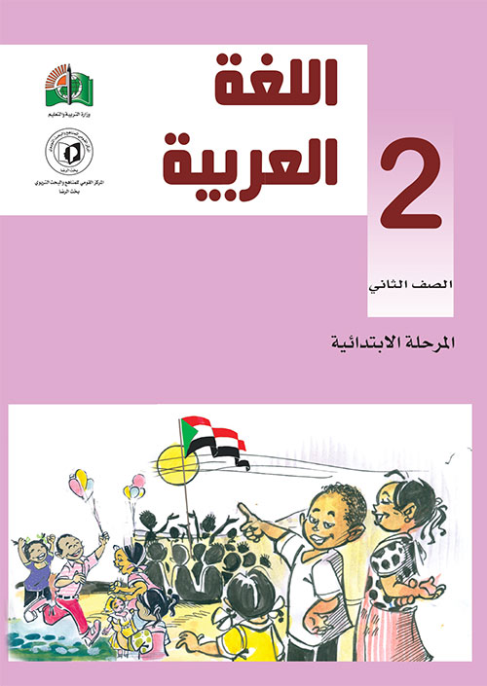](https://www.moe.gov.sd/primbk/arabic2.pdf)

• [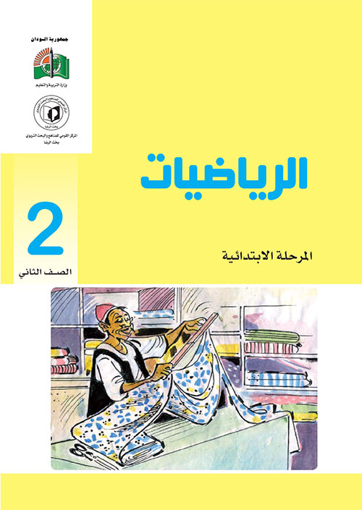](https://www.moe.gov.sd/primbk/math2.pdf)

• [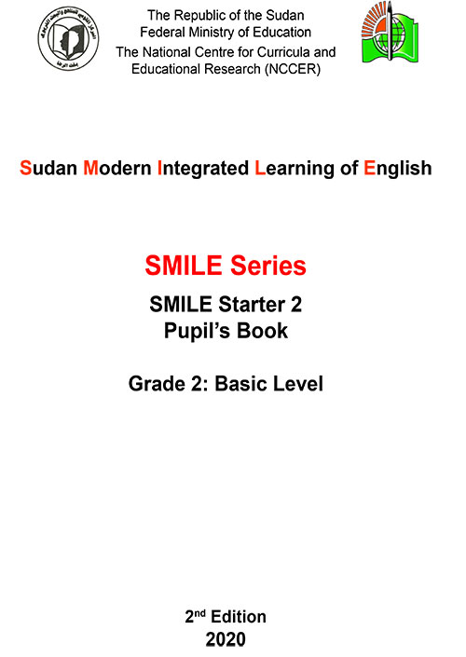](https://www.moe.gov.sd/primbk/english2.pdf)

كتب الصف الثالث

* [Chart, funnel chart

  Description automatically generated](https://www.moe.gov.sd/primbk/islamic3.pdf)
* [Diagram

  Description automatically generated](https://www.moe.gov.sd/primbk/math3.pdf)
* [A picture containing text, solar cell

  Description automatically generated](https://www.moe.gov.sd/primbk/scines3.pdf)
* [Graphical user interface, text, application

  Description automatically generated](https://www.moe.gov.sd/primbk/arabic3.pdf)
* [Graphical user interface

  Description automatically generated](https://www.moe.gov.sd/primbk/english3.pdf)
* [Graphical user interface

  Description automatically generated](https://www.moe.gov.sd/primbk/englishactivity3.pdf)

كتب الصف الرابع

* [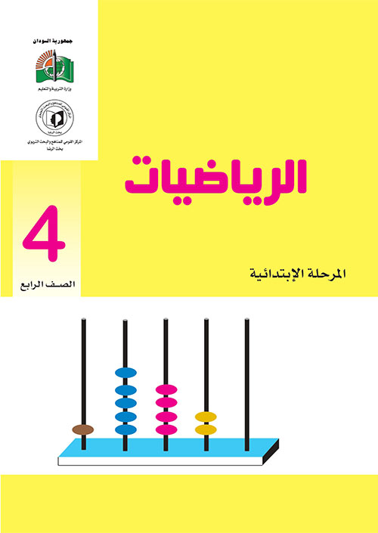](https://www.moe.gov.sd/primbk/math4.pdf)
* [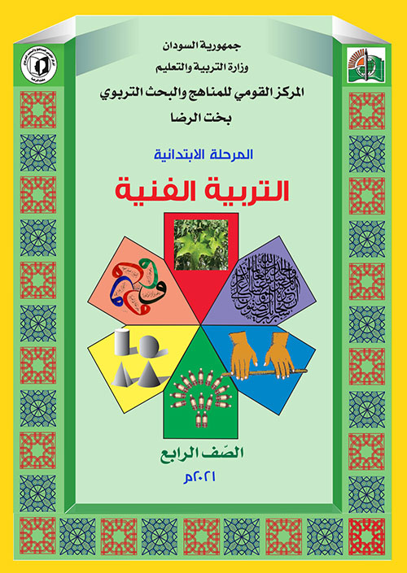](https://www.moe.gov.sd/primbk/phania4.pdf)
* [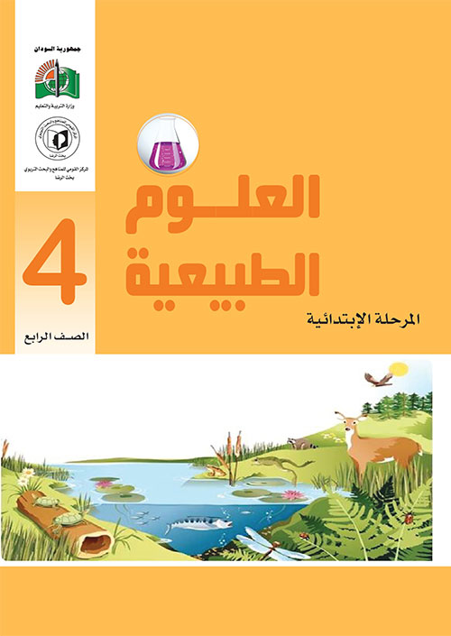](https://www.moe.gov.sd/primbk/scines4.pdf)
* [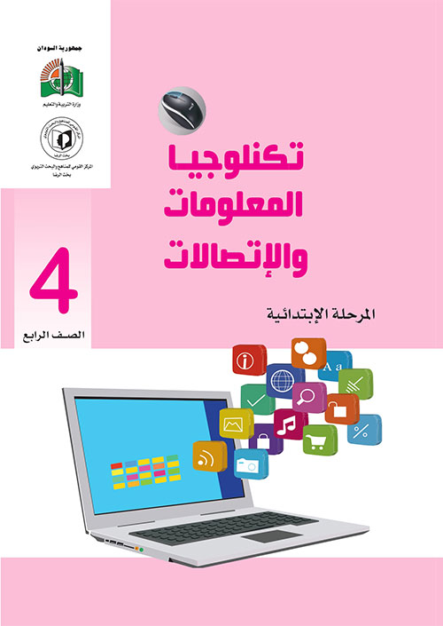](https://www.moe.gov.sd/primbk/comp4.pdf)
* [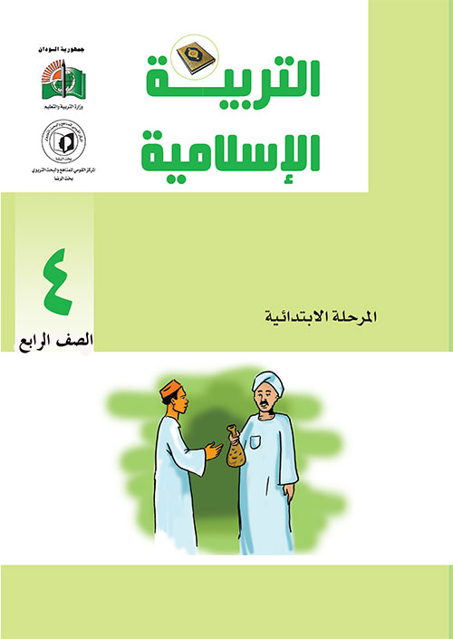](https://www.moe.gov.sd/primbk/islamic4.pdf)
* [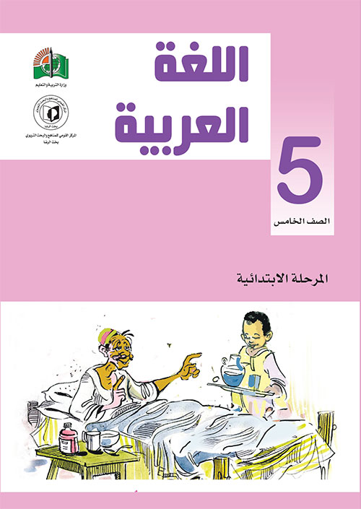](https://www.moe.gov.sd/primbk/arabic5.pdf)
* [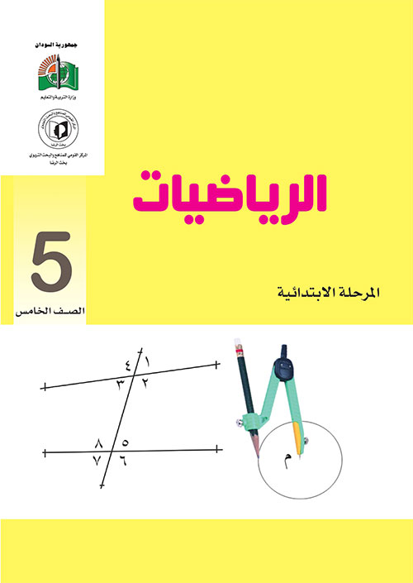](https://www.moe.gov.sd/primbk/math5.pdf)
* [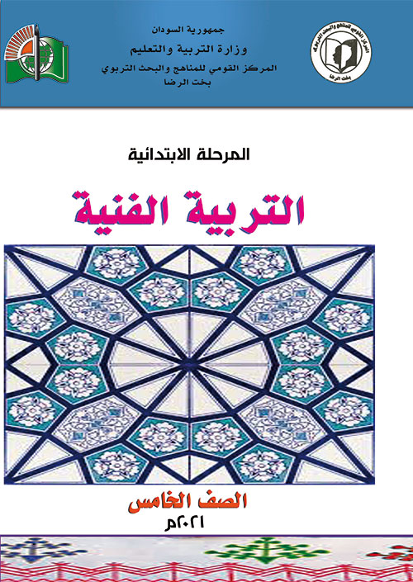](https://www.moe.gov.sd/primbk/phania5.pdf)
* [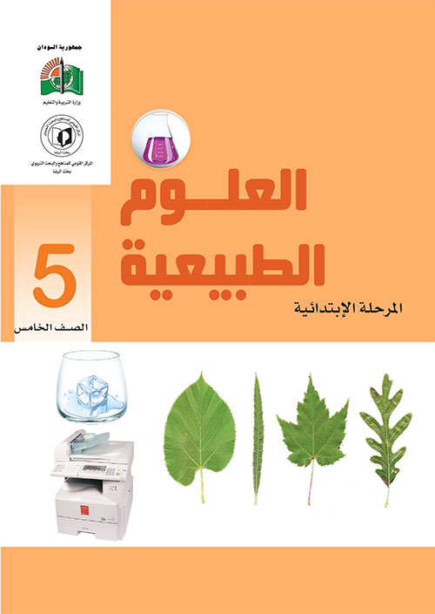](https://www.moe.gov.sd/primbk/scinces5.pdf)
* [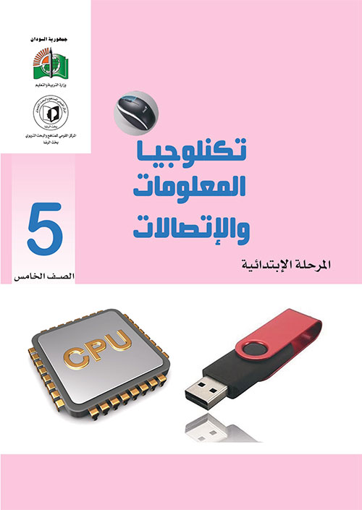](https://www.moe.gov.sd/primbk/comp5.pdf)
* [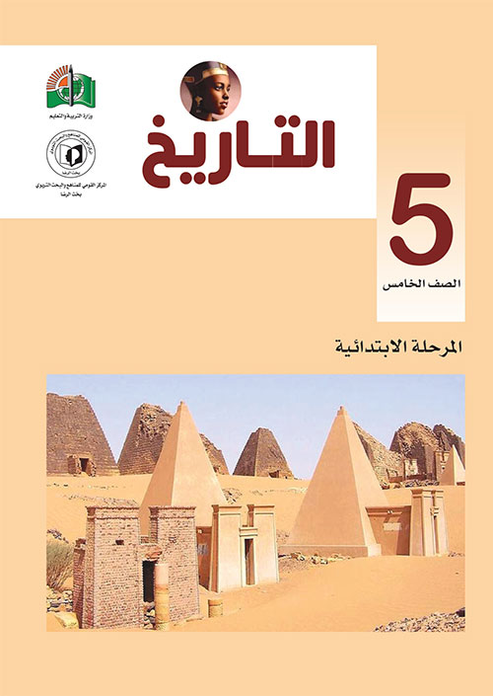](https://www.moe.gov.sd/primbk/history5.pdf)
* [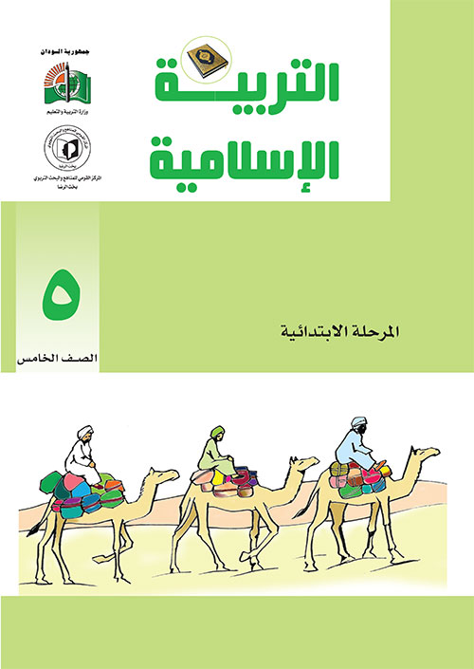](https://www.moe.gov.sd/primbk/islamic5.pdf)
* [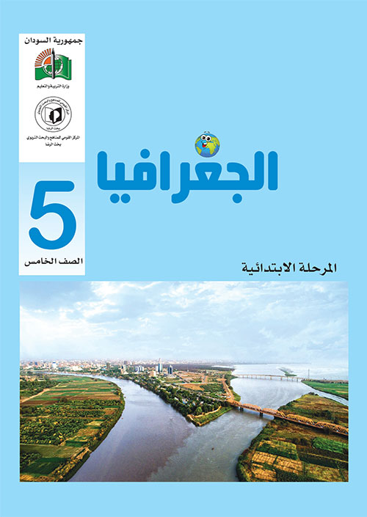](https://www.moe.gov.sd/primbk/gography5.pdf)

[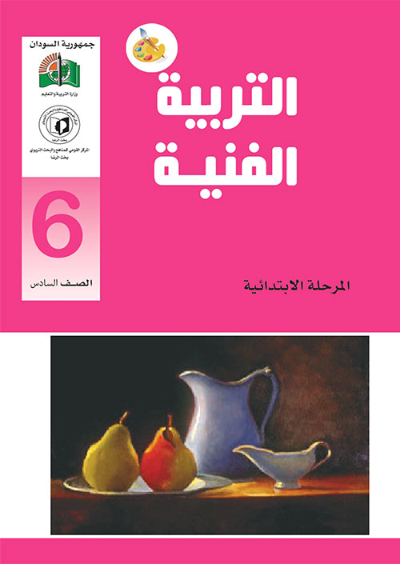](https://www.moe.gov.sd/primbk/phania6.pdf)

كتب الصف الاول متوسط

* [Graphical user interface, application

  Description automatically generated](https://www.moe.gov.sd/intermbk/arabic1.pdf)
* [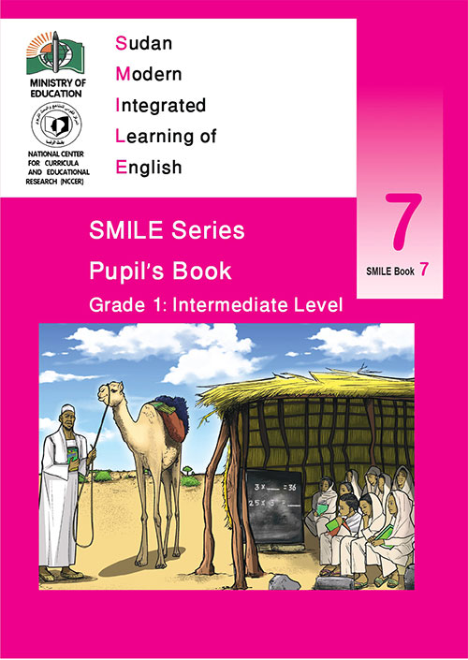](https://www.moe.gov.sd/intermbk/english1.pdf)
* [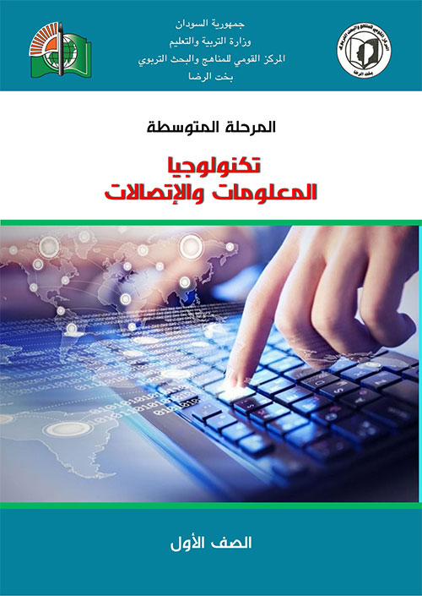](https://www.moe.gov.sd/intermbk/techno1.pdf)
* [Diagram

  Description automatically generated](https://www.moe.gov.sd/intermbk/islamic1.pdf)
* [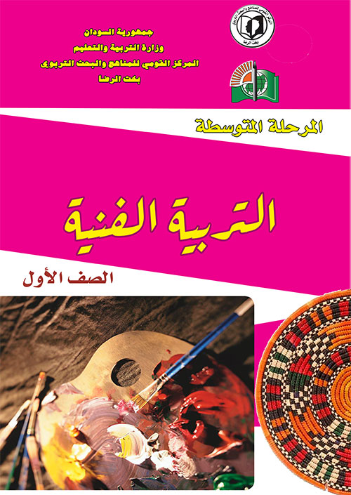](https://www.moe.gov.sd/intermbk/phania1.pdf)
* [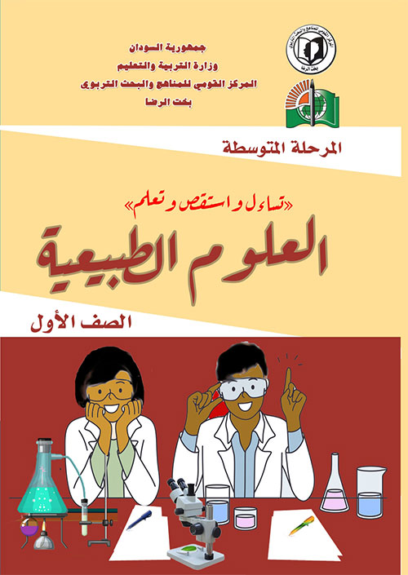](https://www.moe.gov.sd/intermbk/scince1.pdf)
* [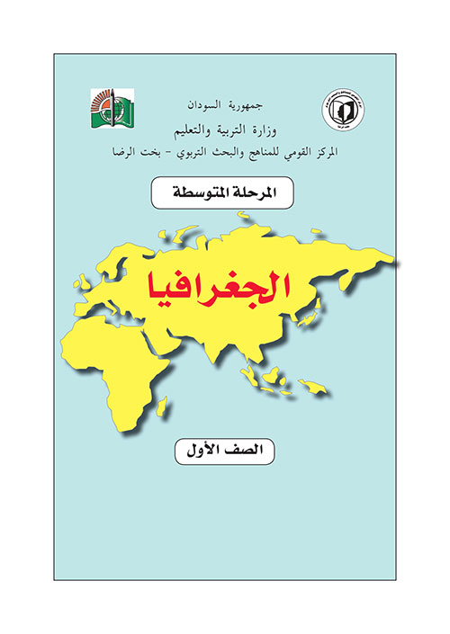](https://www.moe.gov.sd/intermbk/gography1.pdf)
* [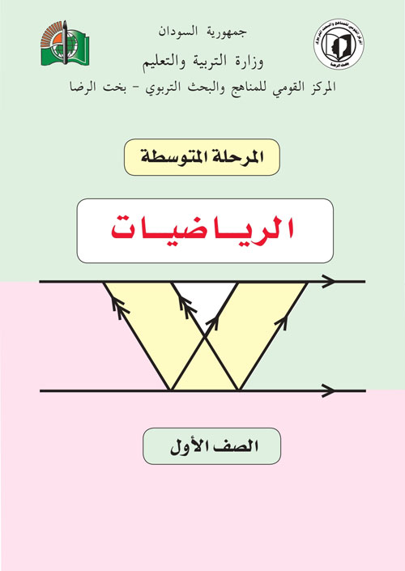](https://www.moe.gov.sd/intermbk/math1.pdf)
* [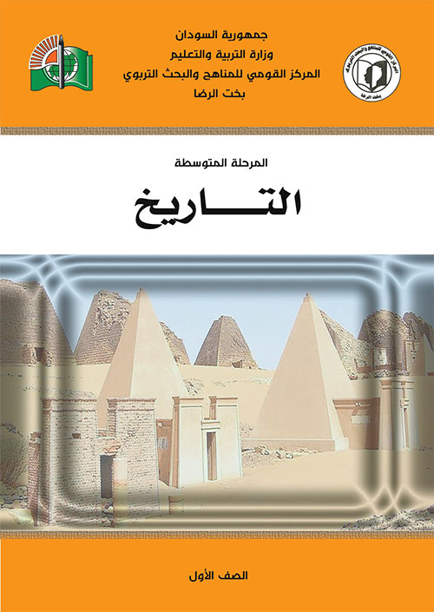](https://www.moe.gov.sd/intermbk/history1.pdf)



